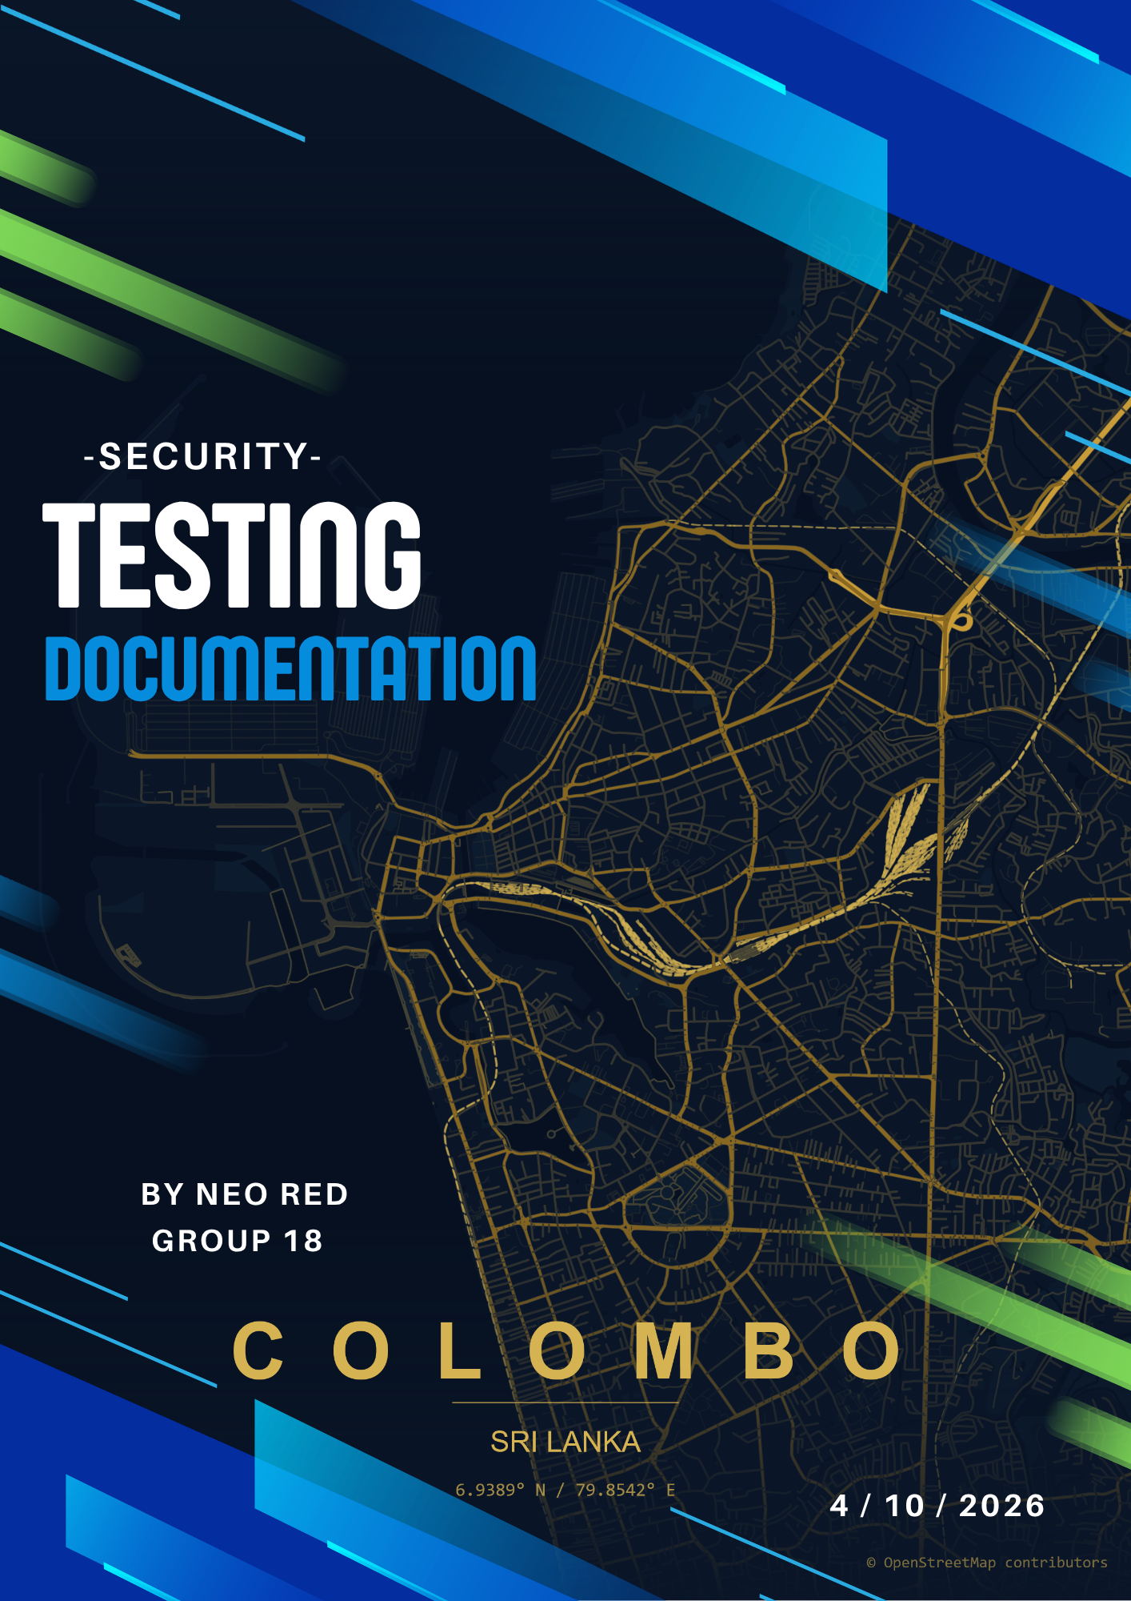

Contents
Vulnerable testing Document 3
Confidentiality statement 3
Engaged parties 3
Project security Scope 3
Executive Summary 4
Risk assessment 4

Vulnerable testing Document

Confidentiality statement
The sensitive contents of this security documentation have been developed by security implementation team of the BUSGO team at of the at the ECU’s applied project class. BUSGO has claimed the following content as its proprietary and confidential information. Due to cyber sensitivity of the information presented, it is only intended to be used for the specific services and uses. It is strictly forbidden to share this document with any other third-party vendor other than its intended parties involved.
Any sharing undertaking must be under specially considered permissions from BUSGO development and the cyber team. I addition to the above-mentioned restrictions, any form of miscommunication, editing and false information may be susceptible to various legal penalties.

Engaged parties
Party contacts
Primary contact | Organization name | Contact email
Neo Red | BUSGO | NRED@our.ecu.edu.au
Nimuthu Ganegoda | BUSGO | NGANEGOD@our.ecu.edu.au
Amiliya Fernando | BUSGO | AMILIYAF@our.ecu.edu.au
Sarasi Mahawattage | BUSGO | SMAHAWAT@our.ecu.edu.au
Ann APPUHAMY | ECU | a.appuhamy@ecu.edu.au
Jethendri PERERA | ECU | jethendriwathsala.perera@ecu.edu.au

Project security Scope
The scope of the project is within strict limitation to the four applications in total, which are defined as,
- BUSGO Axis (Admin panel)
- BUSGO drive
- BUSGO client
- BUSGO scanner
The following test was conducted to analyses the security maturity of the applications mentioned above when it comes to the network operations, configurations of the system and already implemented security guards. Therefore, we will not be covering any additional security frameworks associated with other servers outside of our scope. The main aim of this document is to provide the currently existing application security details and evaluations, which will aid identifying the potential risk and vulnerabilities and their mitigation strategies.

Executive Summary
The security scanning is conducted through a far-reaching professional assessment via diverse number of vulnerabilities known to us. Popular standards that were followed when assessing project security are as follows:
- OWASP Top 10 (Open Worldwide Application Security Project)
- CVE details
- NIST
- ISO/IEC
- SANS institute

Risk assessment
Risk category | Number of vulnerabilities

